Solar Curtailment Project Progress Journal

# 13/09/2022

# Result on Tripping – non clear sky day (sample 1)

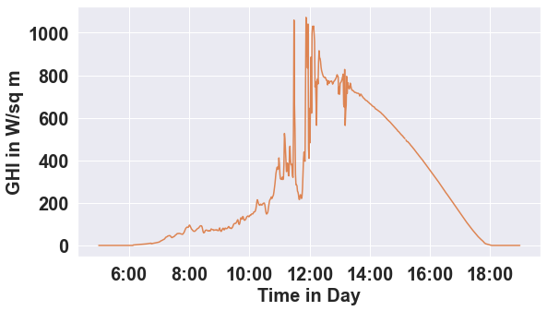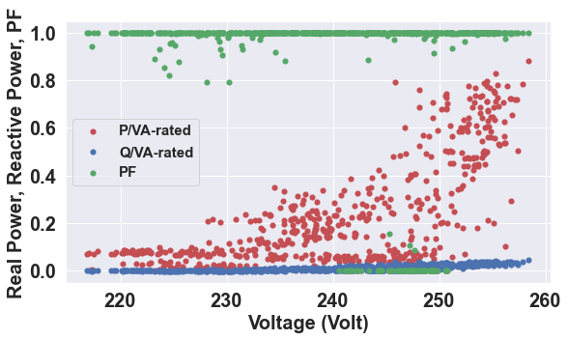

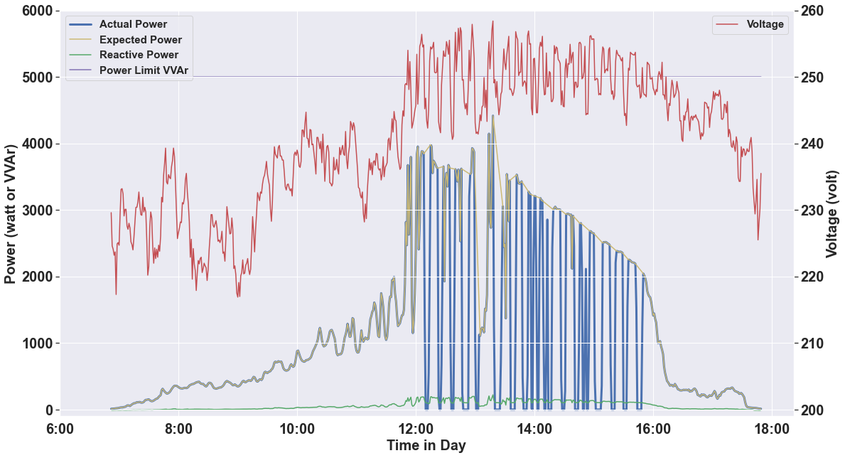

# Result on Tripping – clear sky day (sample 11)

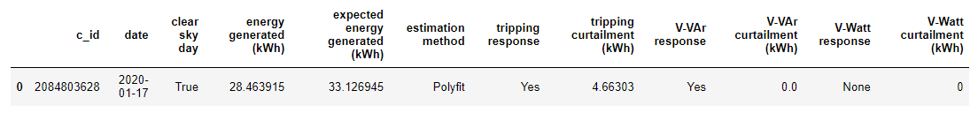

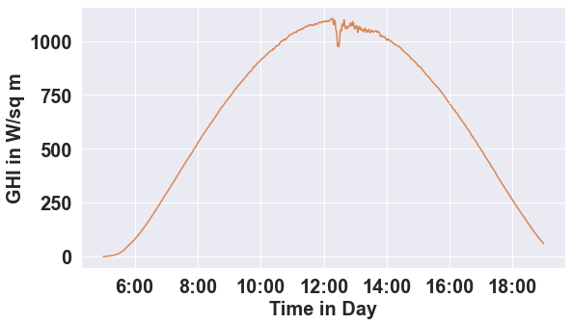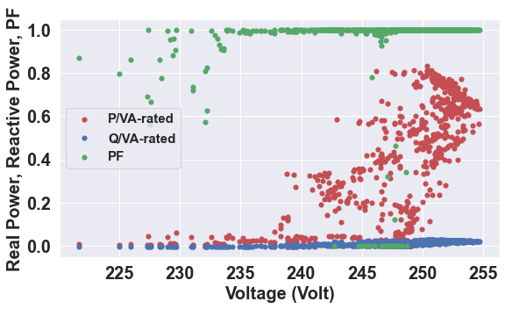

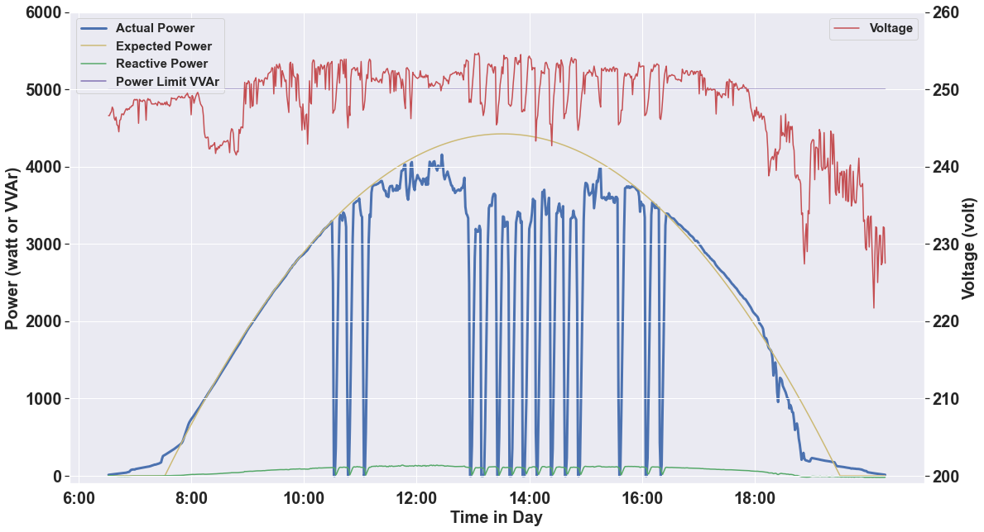

# Result on VVAr (sample 14)

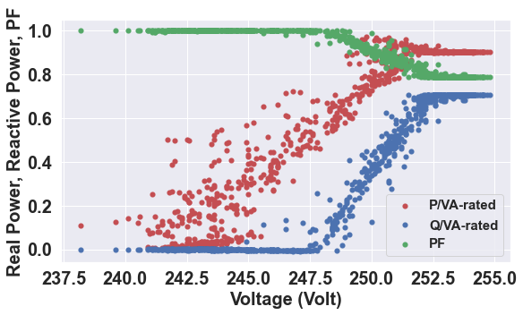

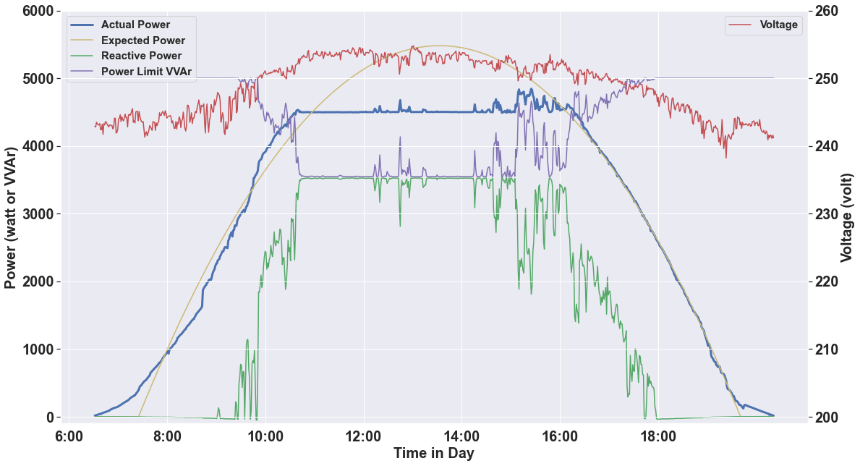

## There are two issues:

1. In the reactive power scatter plot, the Q/VA should have been negative. Problem with polarity correction?
2. In the power and voltage plot, the power limit vvar is below the actual power value. Probably the actual VA limit of the inverter is higher than the ac capacity of the inverter?

# Result on VWatt (sample 4)

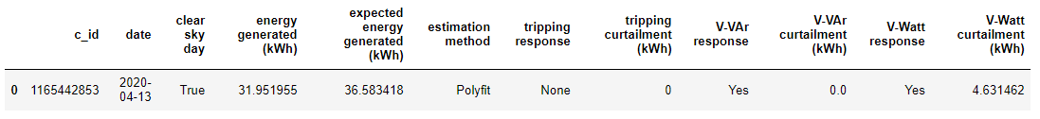

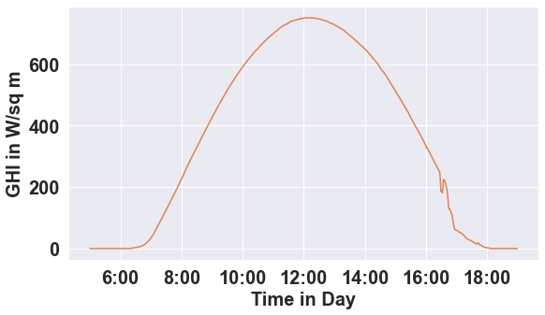 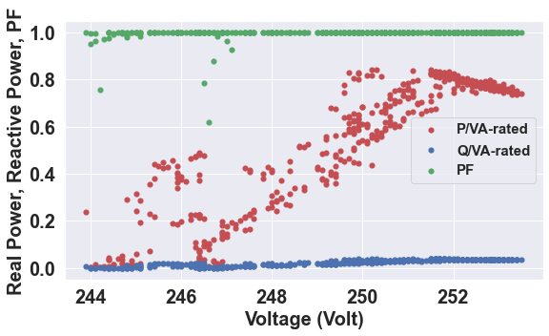

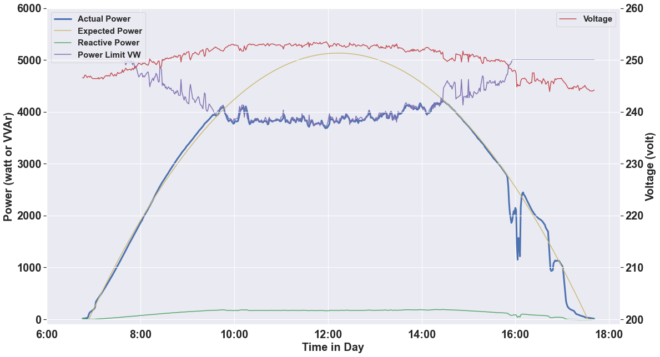

# Result on Incomplete Dataset (sample 5)



The tool will judge the dataset is incomplete only if there are less than 1000 rows in the data. The data should be more than that because the data resolution is either 60 or 5 seconds in SolA dataset.

# Result on No Curtailment Site in Clear Sky Day

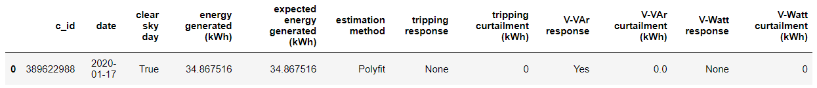

# Polyfit with Constrain Idea Testing

When we implement the polyfit with constrain into a clear sky day without curtailment, it seems we get overestimating:

With constrain:

Without:

Should we give up on this? Or should we still think to optimize it since VWatt calculation is inaccurate and sometime it is underestimating, eg in sample 3:

Without constrain:

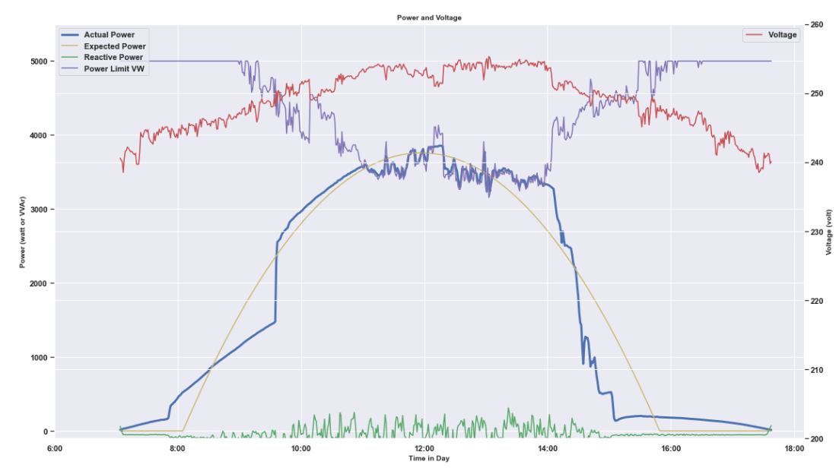

With constrain:

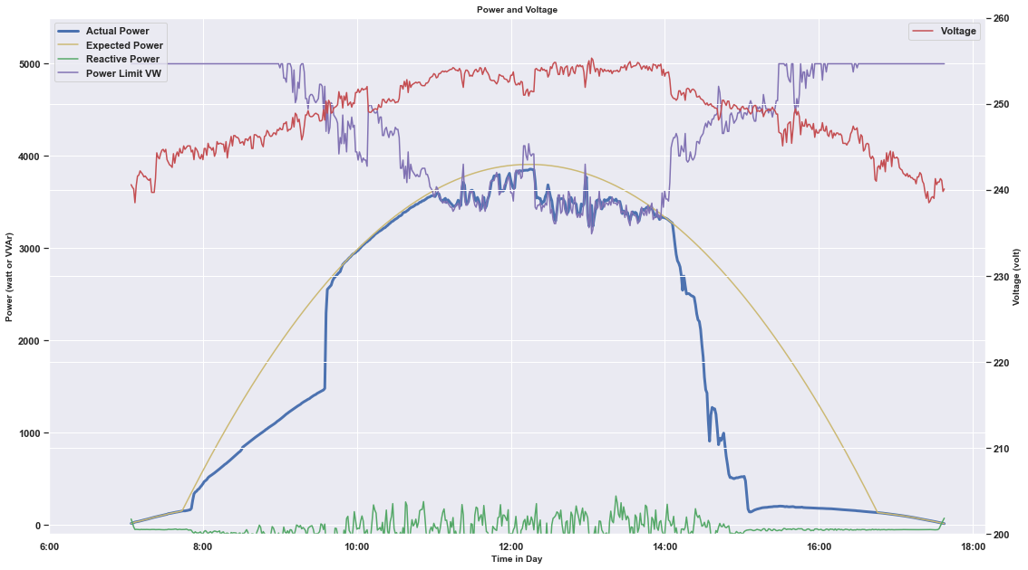

23/9 2022

Documentation

* Function and class docstring are done

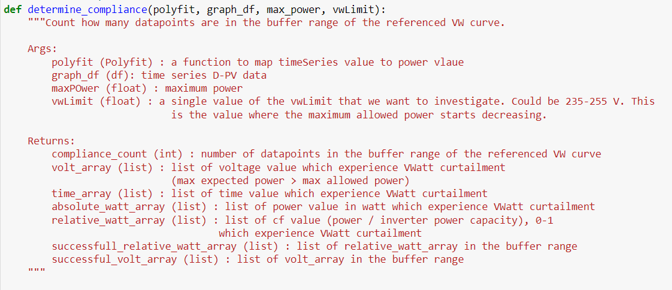

* Naming convention edit is done:
  + Function, variable: lower_case
  + Constant: UPPER_CASE
  + Class: CamelCase
* Readme is done : https://github.com/mssamhan31/Solar-Curtailment
  + About
  + Getting started
  + Tool use demonstration: Screen capture of input, & output
  + High Level Explanation of How The Algorithm Works
  + Tool Limination & notes
  + Some Related Articles and Papers
  + Contributing
  + Project Partners
  + Authors
  + License
  + Contact
* Dataset information is done : <https://github.com/mssamhan31/Solar-Curtailment/blob/main/documentations/solar%20curtailment%20dataset%20information.docx>

# AC Capacity Curtailment

For c_id 198317149, it is clear that the power is curtailed not because of tripping, VVAr, or VWatt response. Rather, it is because the poor sizing of the inverter. The ac capacity of the inverter is too low to accommodate the DC power generated by the PV array. Hence, the power is curtailed by the ac capacity of the inverter. In this case, the ac capacity is 5000 watt.

To accommodate this, we add one condition for the polyfit algorithm: make sure that the expected power generated is never more than the ac capacity of the inverter. Screenshot below:



Result for sample 4:

# Publish the script as a package

The main reference we use is <https://realpython.com/pypi-publish-python-package/> .

## Package Name

As discussed with Baran, we should try to name it with something general without CANVAS word. So, we name it ‘solar-curtailment’, which is still available in PyPI (python package index).

So later, we can install the package using this command.

pip install solar-curtailment

We will, however, try to publish the package to TestPyPI instead of PyPI for the first trial.

# Implementation to a Package

## Transformed the module into package

## Trial in TestPyPI

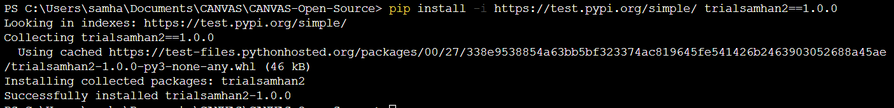

## Issue when changing the version in TestPyPI



Solved. This issue does not happen in pypi. Seems like only happen in TestPyPI.

# Trial in PyPI

Install version 1.0.1

Install version 3.0.0

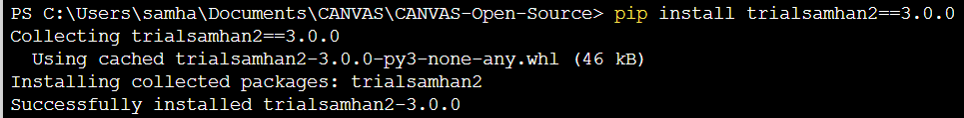

# Reference

Packaging project https://packaging.python.org/en/latest/tutorials/packaging-projects/